Results for female cohort and sensitivity analyses

**Introduction**

This supplementary file contains equivalent Figures to Figures 4 and 5 from the main manuscript for the female cohort, and for the male and female cohort in scenarios where relative rate associated with statin treatment was reduced to 0.65 and 0.6, and when treatment periods consisting of only one statin prescription were removed from the cohort. For the primary analysis done on the female cohort, we also provide equivalent illustrative examples to the ones provided in the main paper.

**Key for supplementary figures**

|  |  |  |  |  |  |
| --- | --- | --- | --- | --- | --- |
|  | Gender | Adherence rate | Single prescriptions removed | RR of statin | Page |
| Figure 1 – primary analysis for female cohort | F | CPRD | N | 0.7 | 3 |
| Figure 2 – primary analysis for female cohort | F | Adjusted | N | 0.7 | 5 |
| Figure 3 | M | CPRD | N | 0.65 | 7 |
| Figure 4 | M | CPRD | N | 0.6 | 8 |
| Figure 5 | M | CPRD | Y | 0.7 | 9 |
| Figure 6 | M | CPRD | Y | 0.65 | 10 |
| Figure 7 | M | CPRD | Y | 0.6 | 11 |
| Figure 8 | M | Adjusted | N | 0.65 | 12 |
| Figure 9 | M | Adjusted | N | 0.6 | 13 |
| Figure 10 | M | Adjusted | Y | 0.7 | 14 |
| Figure 11 | M | Adjusted | Y | 0.65 | 15 |
| Figure 12 | M | Adjusted | Y | 0.6 | 16 |
| Figure 13 | F | CPRD | N | 0.65 | 17 |
| Figure 14 | F | CPRD | N | 0.6 | 18 |
| Figure 15 | F | CPRD | Y | 0.7 | 19 |
| Figure 16 | F | CPRD | Y | 0.65 | 20 |
| Figure 17 | F | CPRD | Y | 0.6 | 21 |
| Figure 18 | F | Adjusted | N | 0.65 | 22 |
| Figure 19 | F | Adjusted | N | 0.6 | 23 |
| Figure 20 | F | Adjusted | Y | 0.7 | 24 |
| Figure 21 | F | Adjusted | Y | 0.65 | 25 |
| Figure 22 | F | Adjusted | Y | 0.6 | 26 |

**Discussion of results**

The primary analysis for the female cohort beings similar conclusions to the male cohort. The peak of the trajectories is driven by age, rather than risk score, although the peak is shifted by about five years to just after 60. This reflects female’s lower risk of death. Again there is little gain to be made by delaying statin initiation until patients are at a higher risk.

The rest of the sensitivity analyses echo the findings from the primary analysis. Reducing the relative rate (increasing the treatment effect) causes a higher number of events prevented, however the shape of the trajectories remains the same and the maxima is around the same age. While there is a bigger difference between prescribing at age 40 and age 60, the time period of most interest (between 50 and 70) shows little benefit to delaying. When the cohort of statin users excludes treatment periods with only one prescription, the events prevented increases slightly but the change is not large. Once again, the maxima of the trajectories are at a similar point.

The sensitivity analyses support the main findings from the study.

Supplementary Figure 3.1: Number of cardiovascular events prevented over the duration of follow up with different time delays in starting statins, stratified by baseline age and 10 year CVD risk using the discontinuation rates as observed in the statin cohort **(female cohort)**

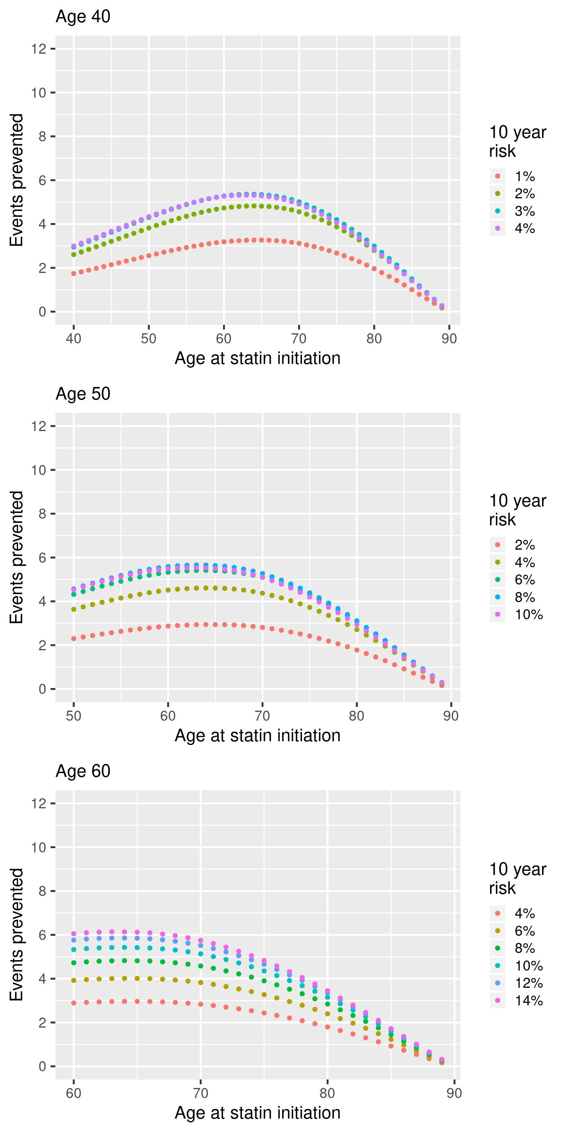

*Supplementary illustrative example 1:* If we prescribe statins to a cohort of 50-year old men with a 10% 10-year CVD risk, we prevent 4.53 events per 100 individuals over the course of 40 years. If we took this same cohort of women, but instead waited 10 years before initiating statins, at which point there 10-year risk of CVD would be around 20%, then we would prevent 5.49 events per 100 individuals over the 40 years period of follow up.

Supplementary Figure 3.2: Number of cardiovascular events prevented over the duration of follow up with different time delays in starting statins, stratified by baseline age and discontinuation rate **(female cohort)**

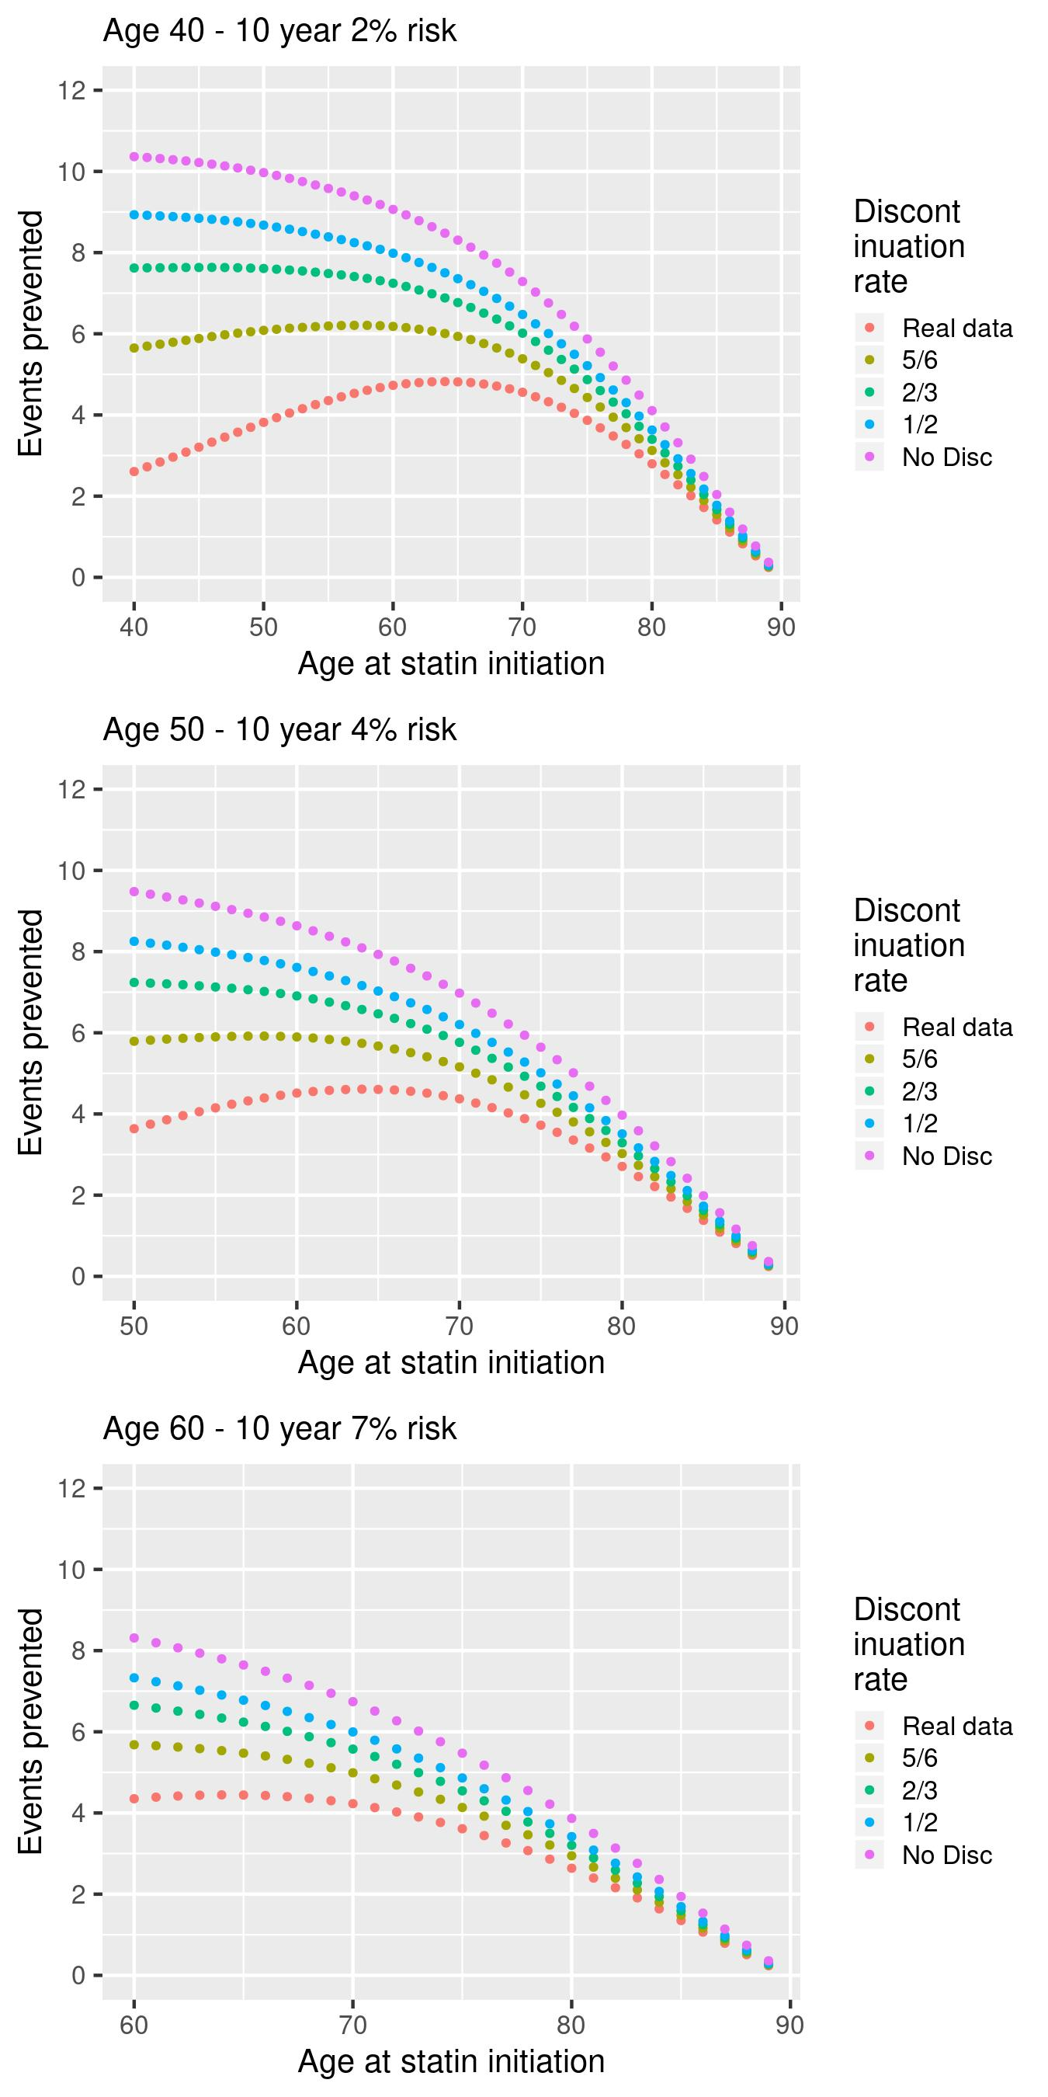

*Supplementary illustrative example 2:* Consider prescribing statins to a cohort of 50-year old women with a 4% 10-year CVD risk (median for that group). Per 100 individuals, 3.64 events are prevented if discontinuation rates remain as normal, 5.79 events if discontinuation is reduced by a sixth, 7.24 events if discontinuation is reduced by a third, 8.25 events if discontinuation is halved, and 9.47 events if there is no discontinuation. The equivalent number of events prevented for a cohort with 10% 10-year CVD risk are 4.54, 7.21, 9.05, 10.27 and 11.83.

Supplementary Figure 3.3: Number of cardiovascular events prevented over the duration of follow up with different time delays in starting statins, stratified by baseline age and 10 year CVD risk using the discontinuation rates as observed in the statin cohort **(male cohort, RR = 0.65)**

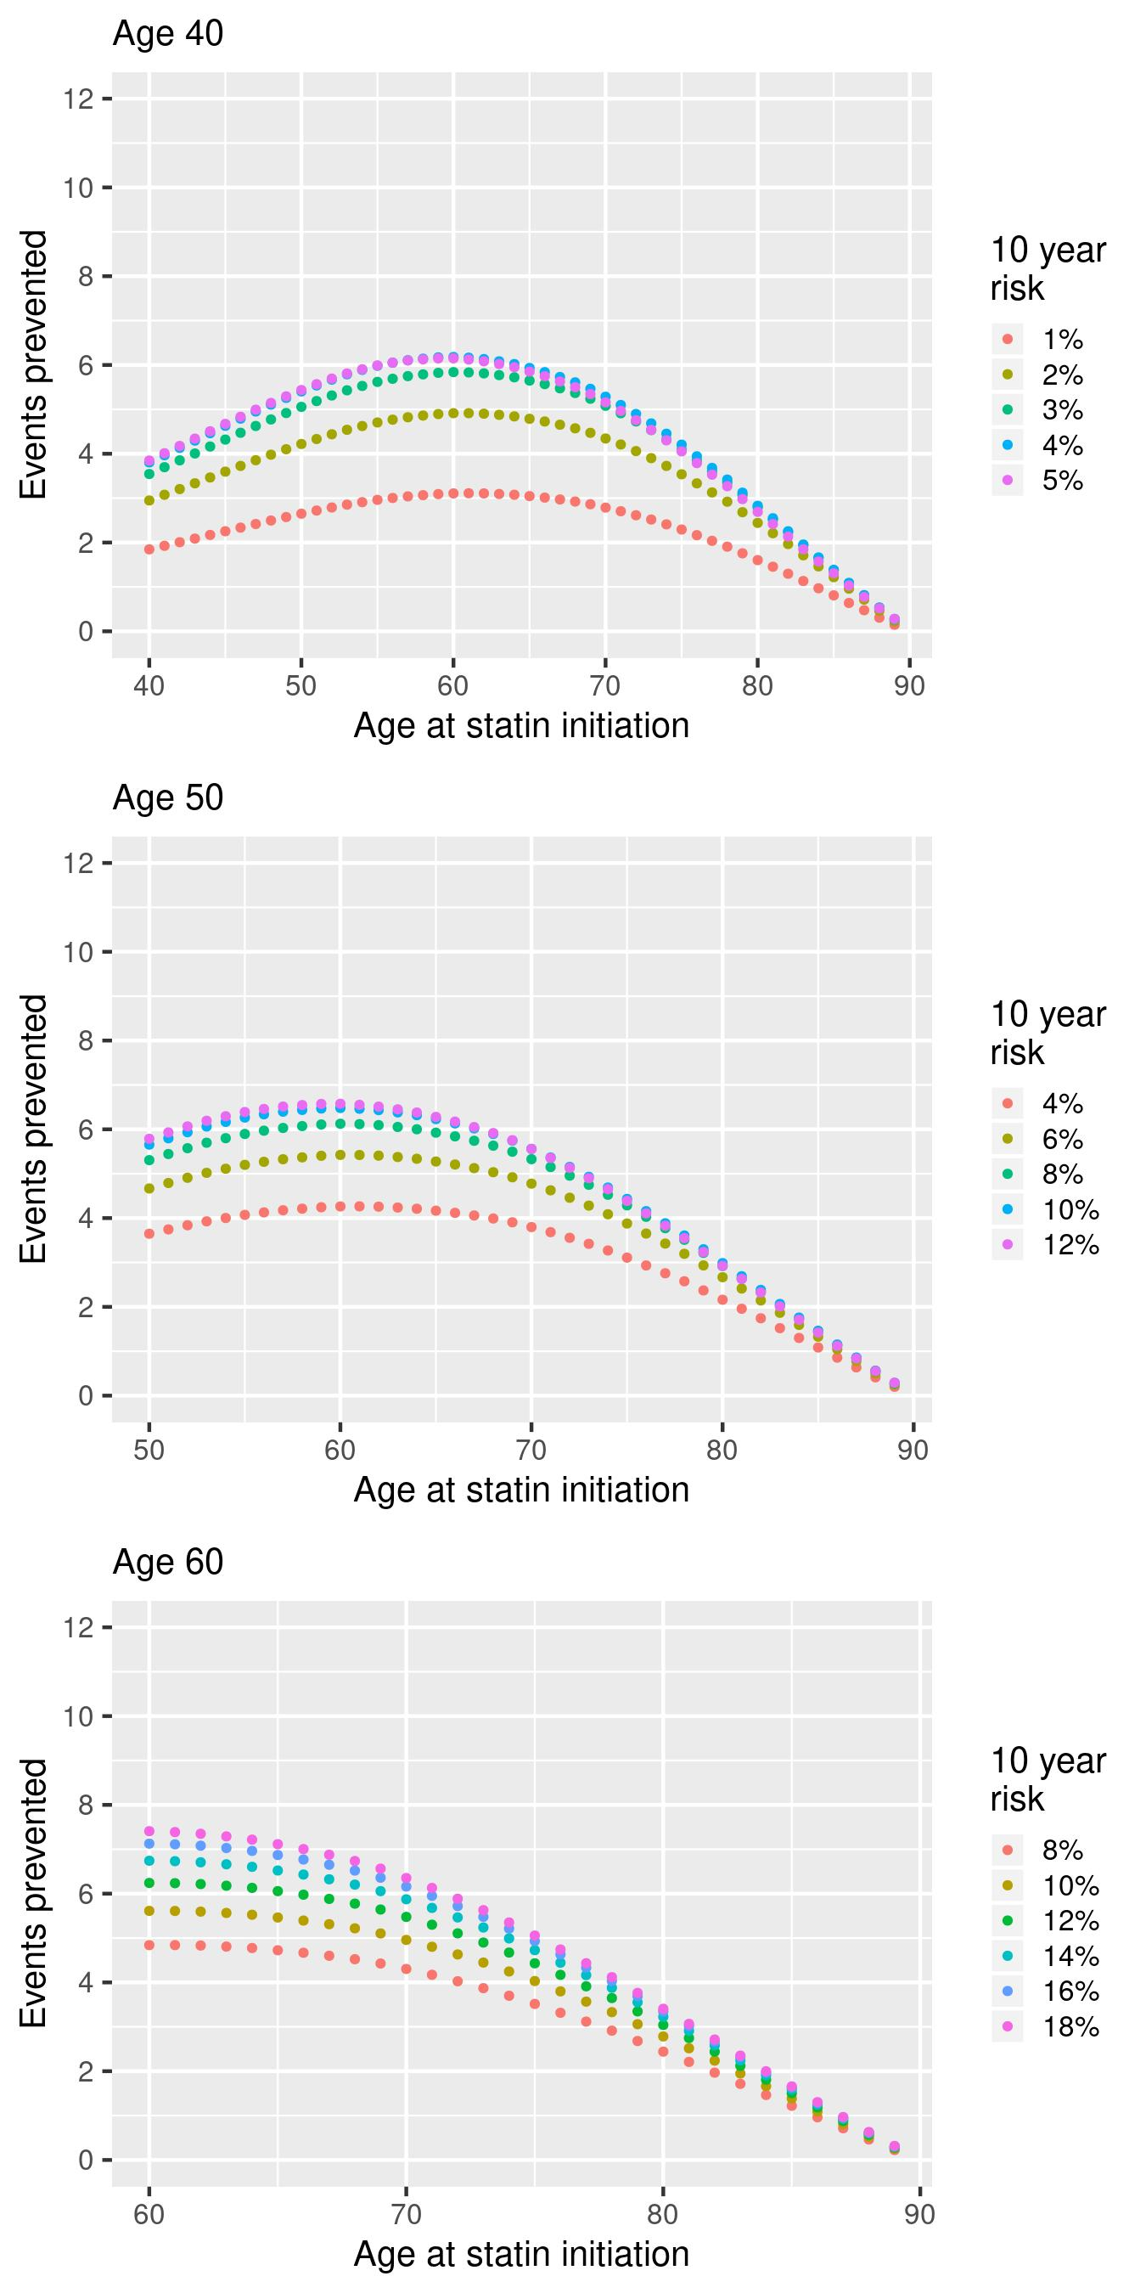

Supplementary Figure 3.4: Number of cardiovascular events prevented over the duration of follow up with different time delays in starting statins, stratified by baseline age and 10 year CVD risk using the discontinuation rates as observed in the statin cohort **(male cohort, RR = 0.6)**

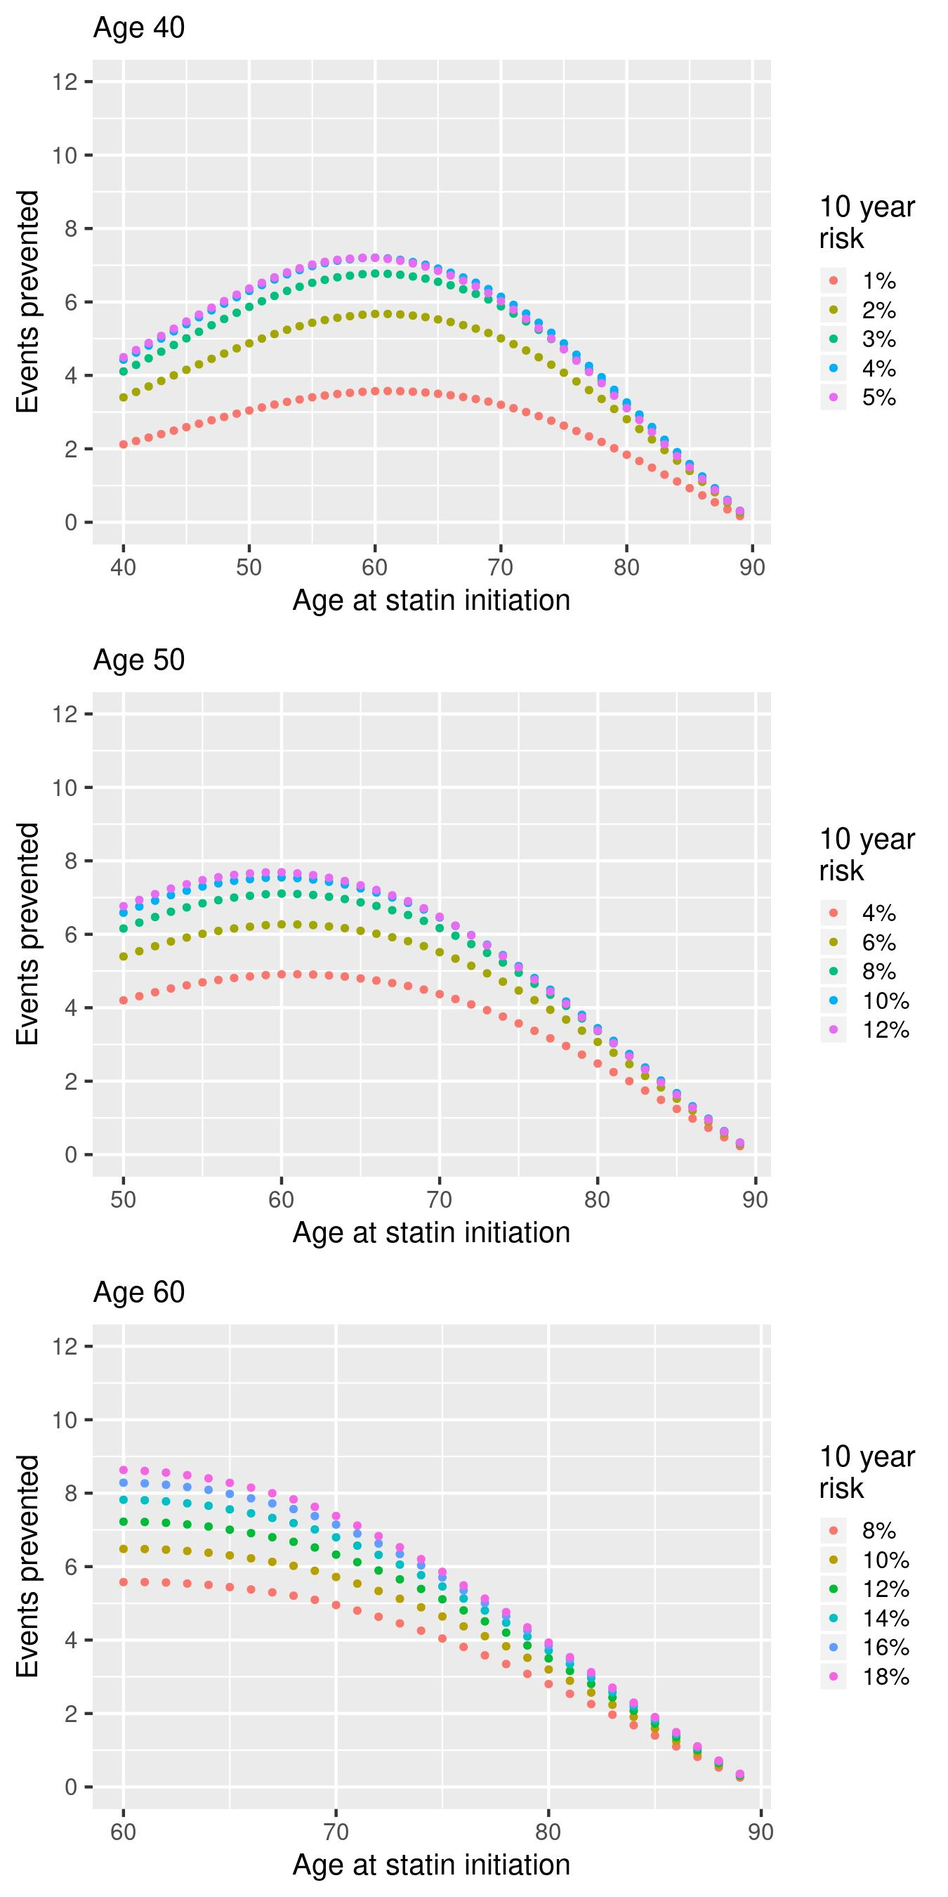

Supplementary Figure 3.5: Number of cardiovascular events prevented over the duration of follow up with different time delays in starting statins, stratified by baseline age and 10 year CVD risk using the discontinuation rates as observed in the statin cohort **(male cohort, RR = 0.7, single prescriptions excluded)**

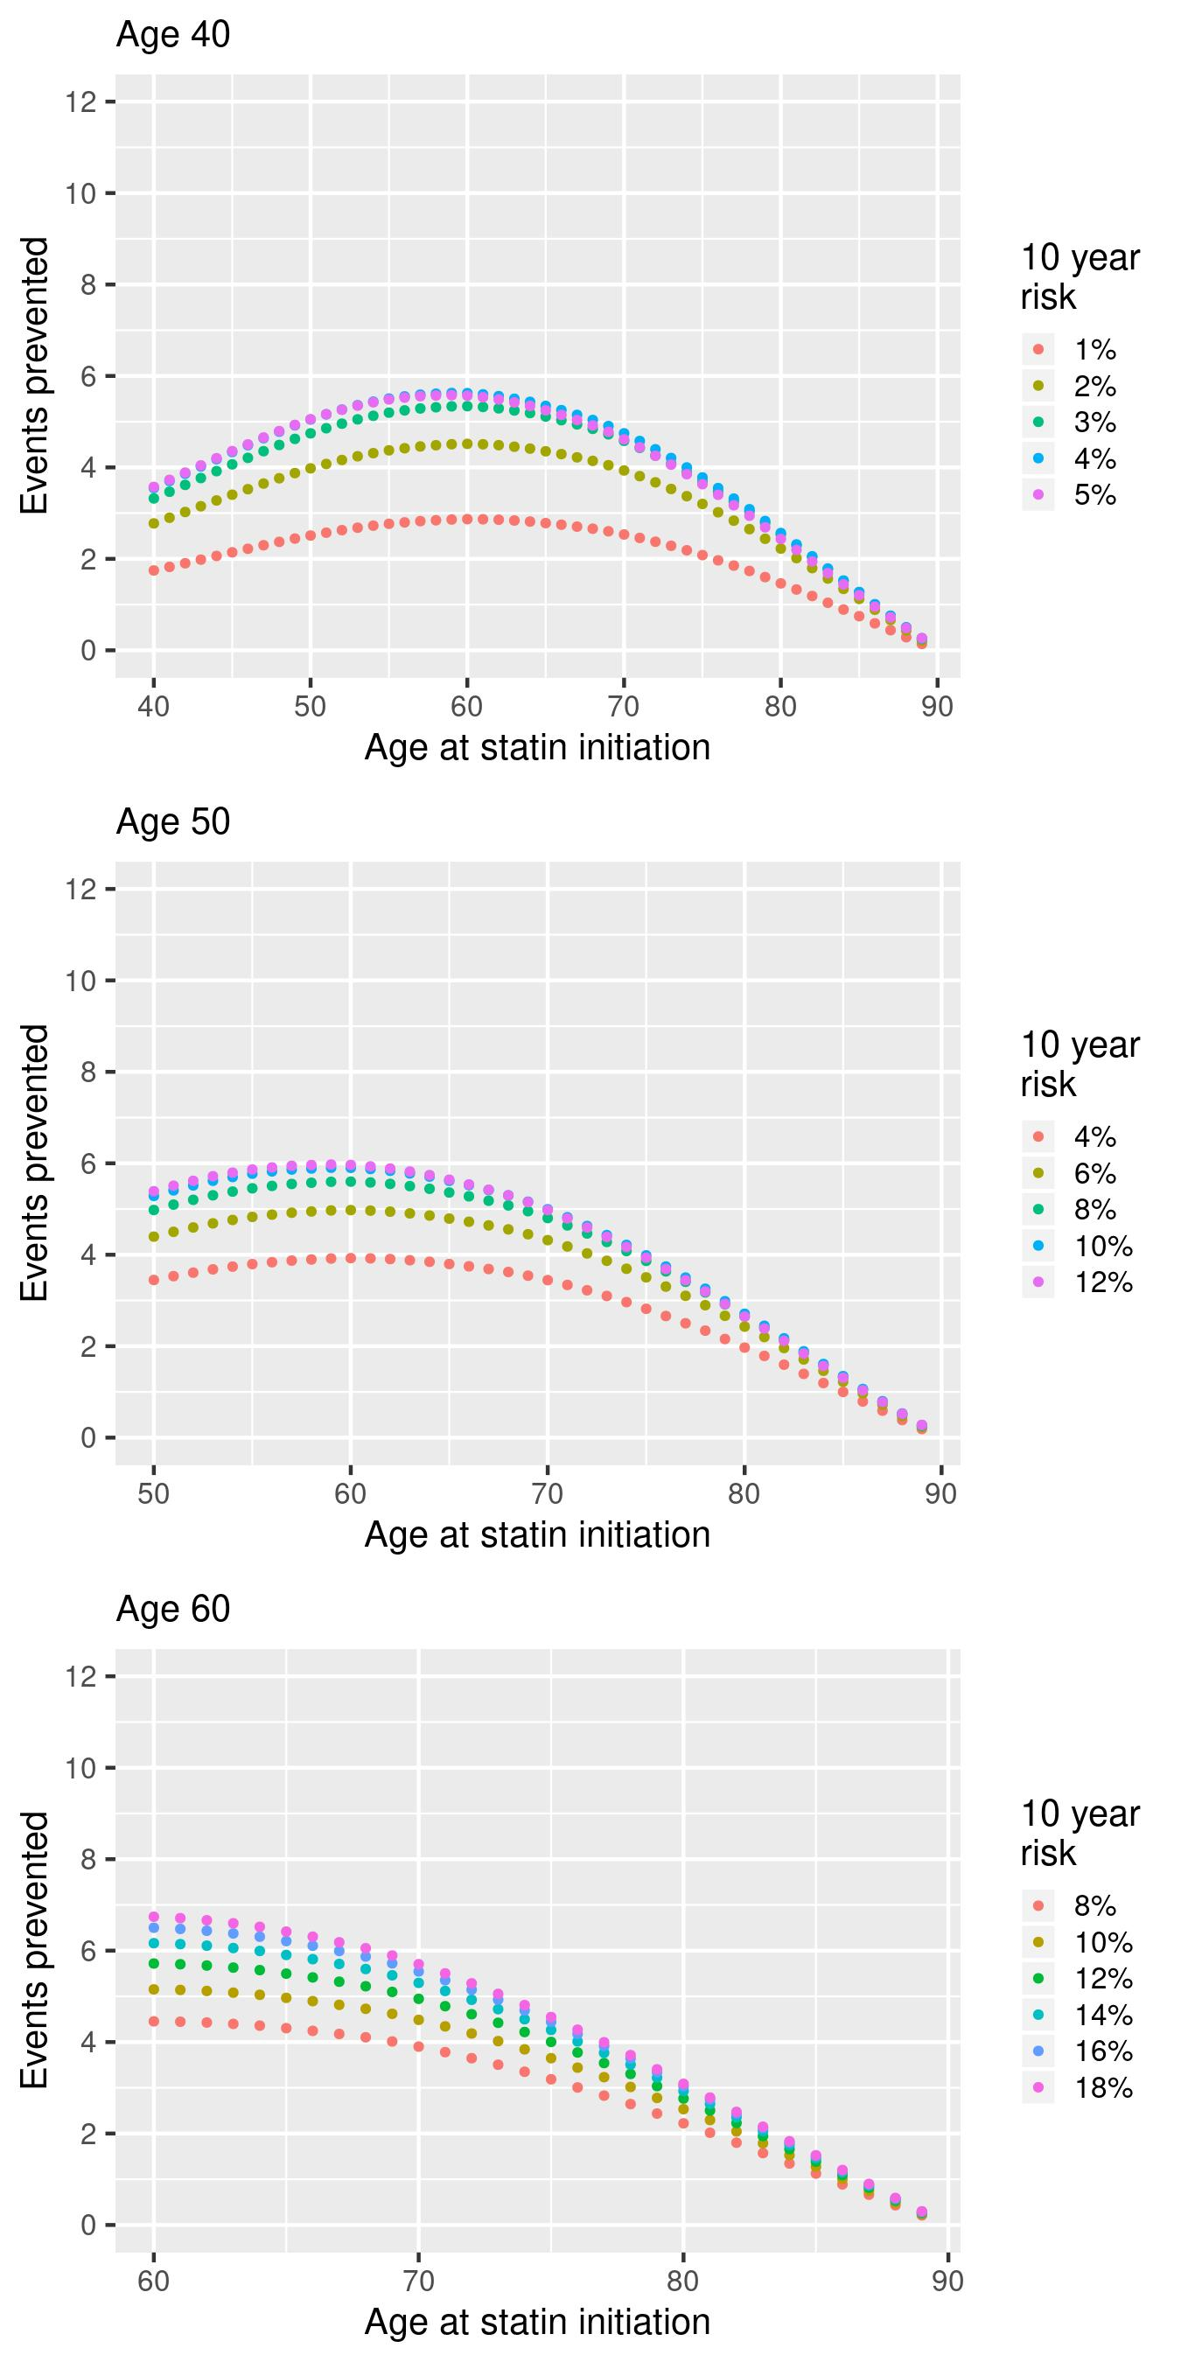

Supplementary Figure 3.6: Number of cardiovascular events prevented over the duration of follow up with different time delays in starting statins, stratified by baseline age and 10 year CVD risk using the discontinuation rates as observed in the statin cohort **(male cohort, RR = 0.65, single prescriptions excluded)**

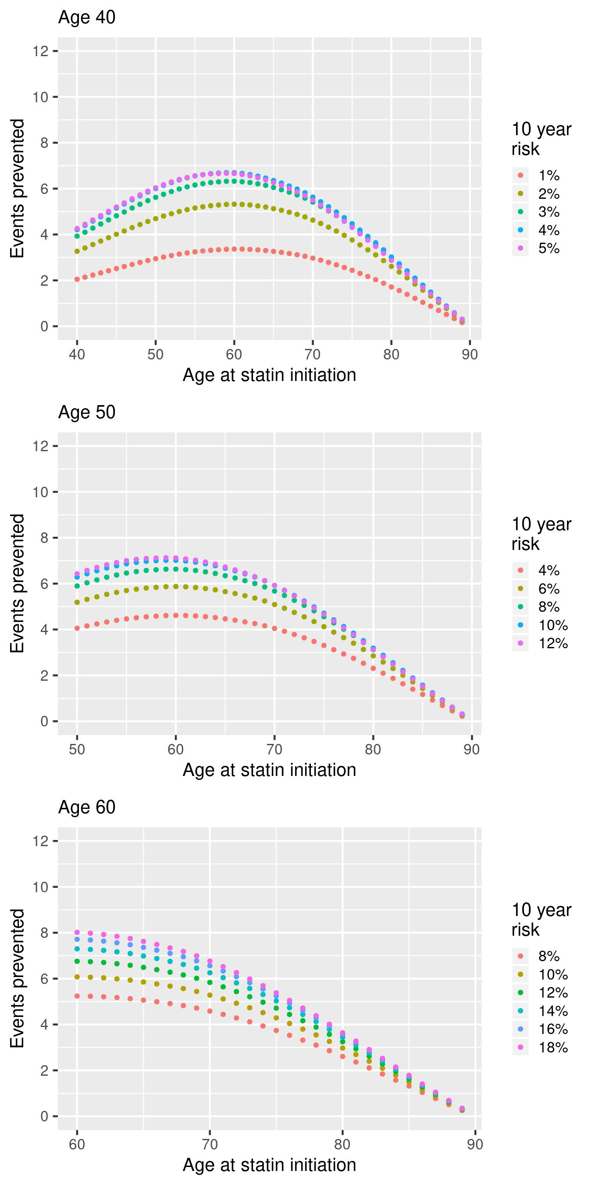

Supplementary Figure 3.7: Number of cardiovascular events prevented over the duration of follow up with different time delays in starting statins, stratified by baseline age and 10 year CVD risk using the discontinuation rates as observed in the statin cohort **(male cohort, RR = 0.6, single prescriptions excluded)**

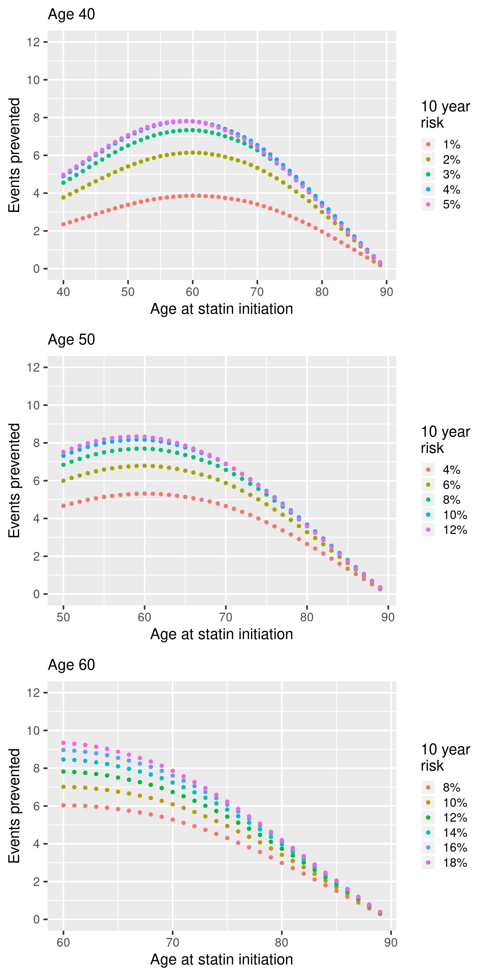

Supplementary Figure 3.8: Number of cardiovascular events prevented over the duration of follow up with different time delays in starting statins, stratified by baseline age and discontinuation rate **(male cohort, RR = 0.65)**

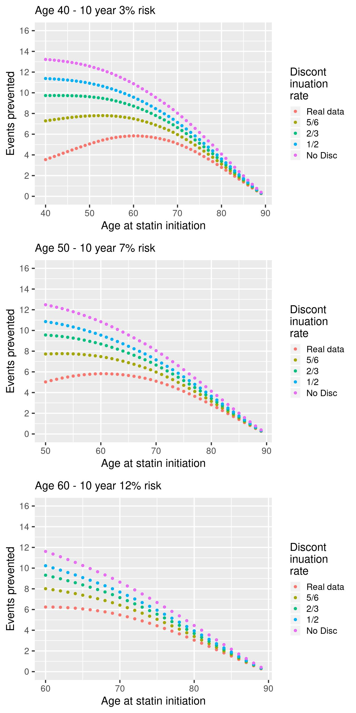

Supplementary Figure 3.9: Number of cardiovascular events prevented over the duration of follow up with different time delays in starting statins, stratified by baseline age and discontinuation rate **(male cohort, RR = 0.6)**

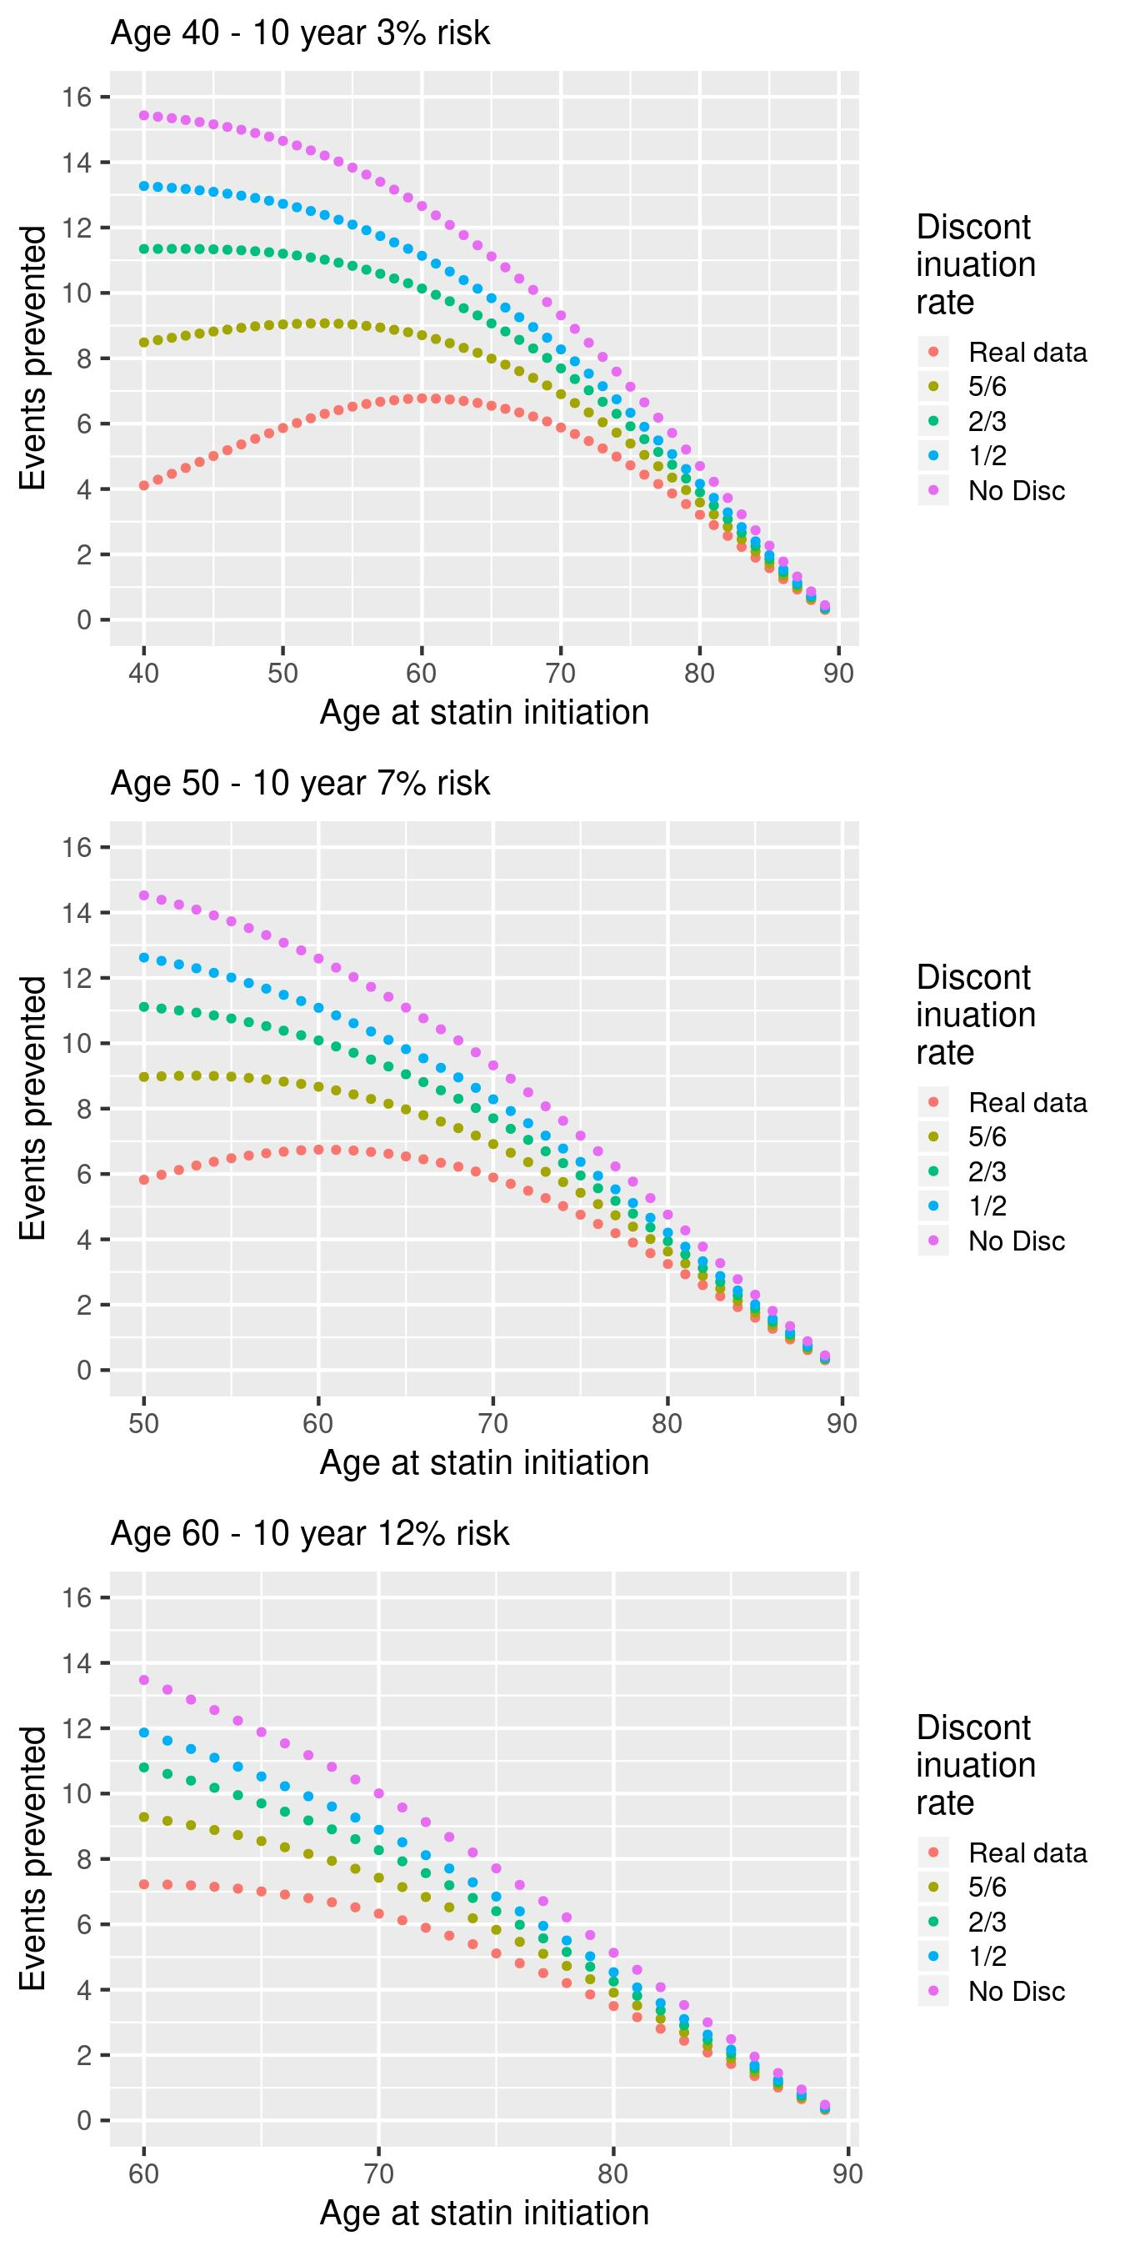

Supplementary Figure 3.10: Number of cardiovascular events prevented over the duration of follow up with different time delays in starting statins, stratified by baseline age and discontinuation rate **(male cohort, RR = 0.7, single prescriptions excluded)**

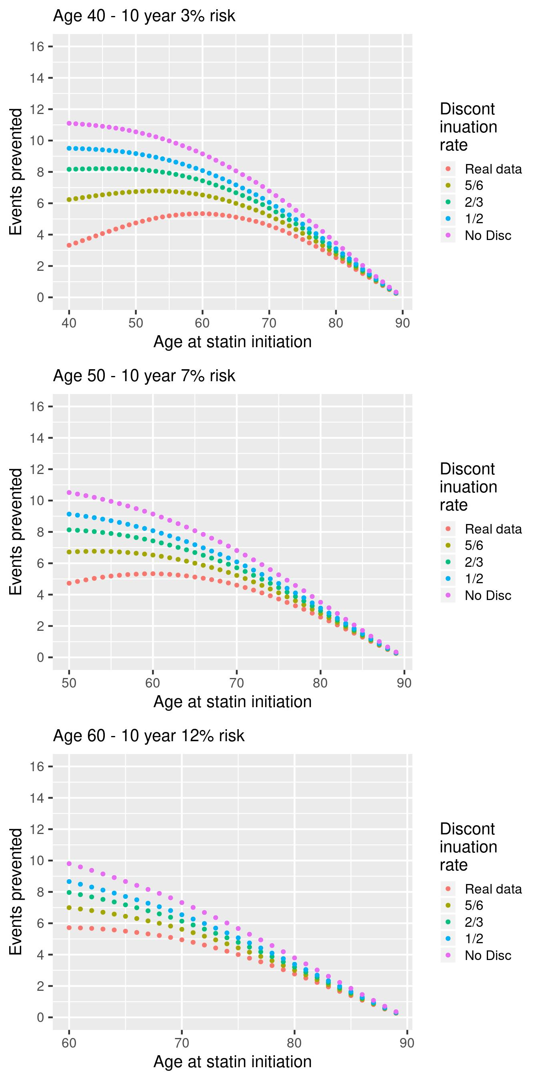

Supplementary Figure 3.11: Number of cardiovascular events prevented over the duration of follow up with different time delays in starting statins, stratified by baseline age and discontinuation rate **(male cohort, RR = 0.65, single prescriptions excluded)**

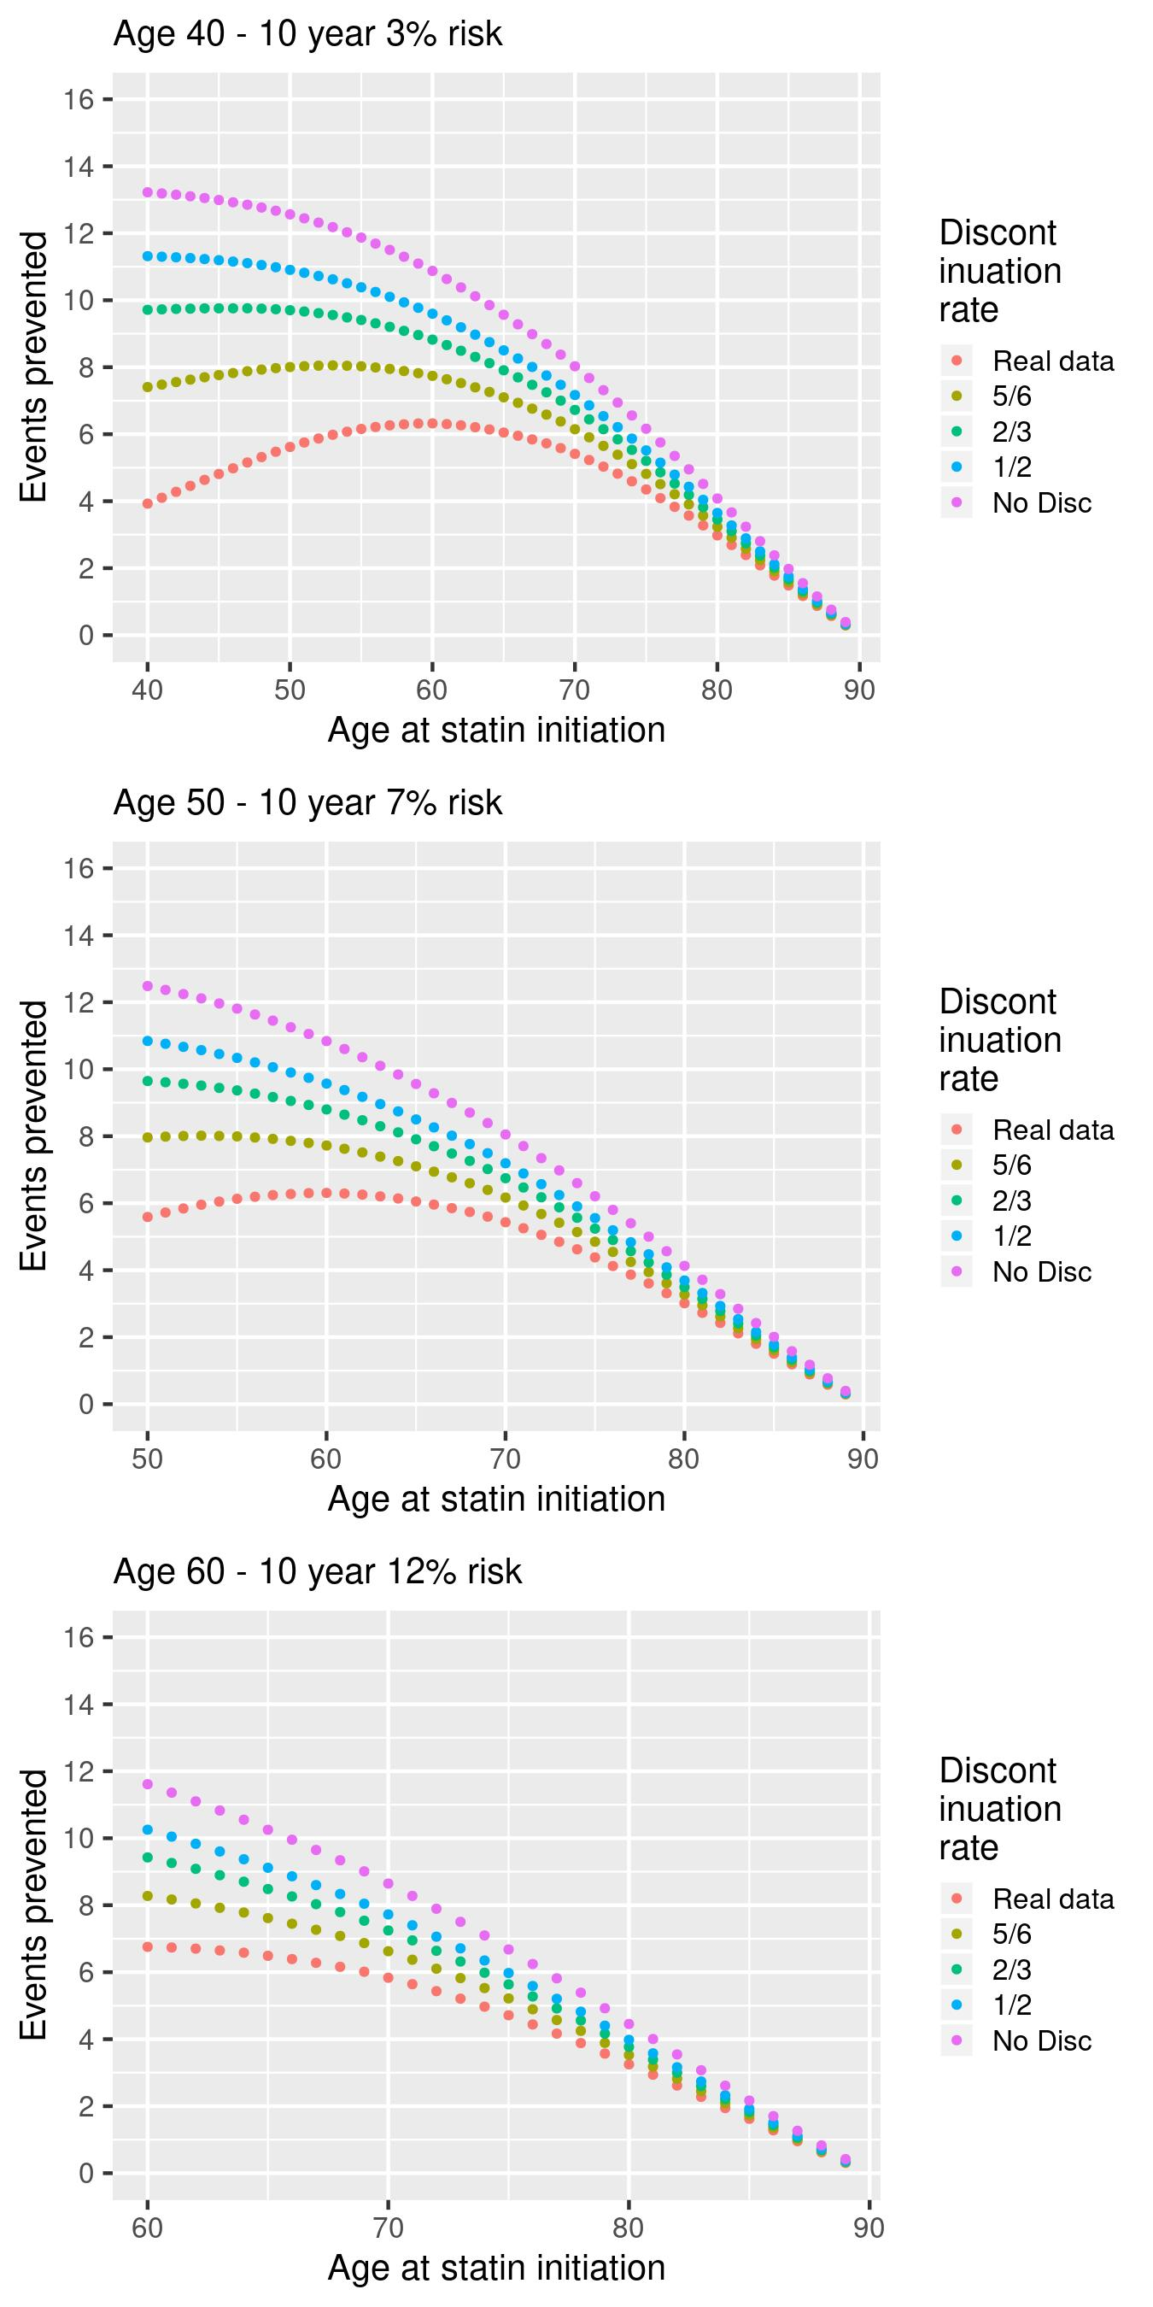

Supplementary Figure 3.12: Number of cardiovascular events prevented over the duration of follow up with different time delays in starting statins, stratified by baseline age and discontinuation rate **(male cohort, RR = 0.6, single prescriptions excluded)**

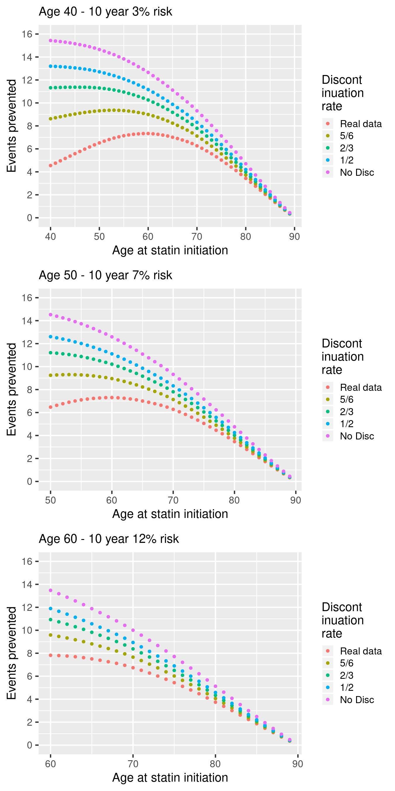

Supplementary Figure 3.13: Number of cardiovascular events prevented over the duration of follow up with different time delays in starting statins, stratified by baseline age and 10 year CVD risk using the discontinuation rates as observed in the statin cohort **(female cohort, RR = 0.65)**

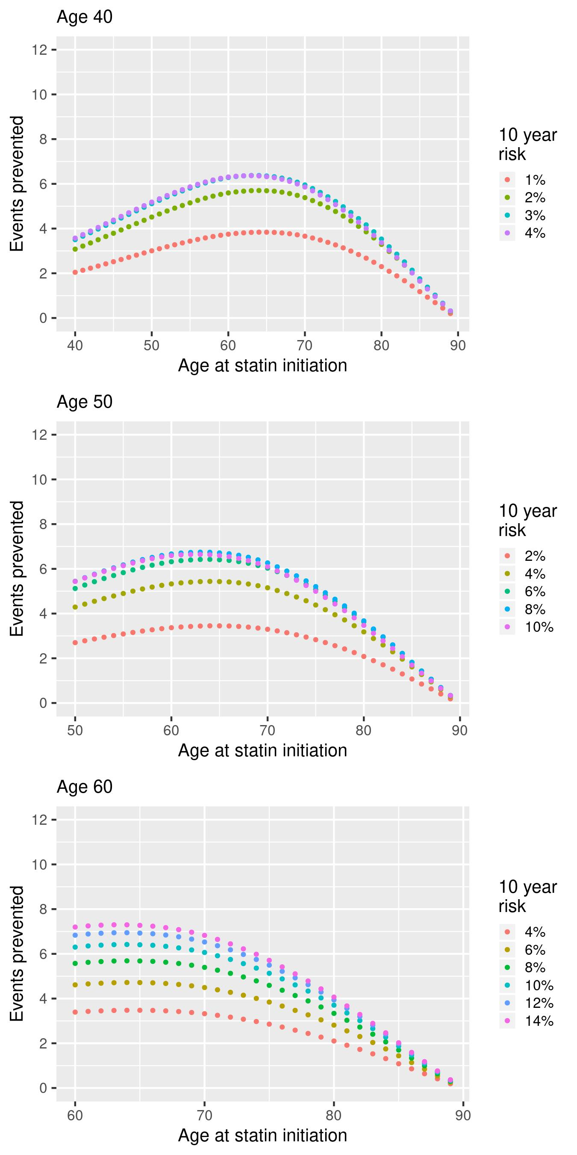

Supplementary Figure 3.14: Number of cardiovascular events prevented over the duration of follow up with different time delays in starting statins, stratified by baseline age and 10 year CVD risk using the discontinuation rates as observed in the statin cohort **(female cohort, RR = 0.6)**

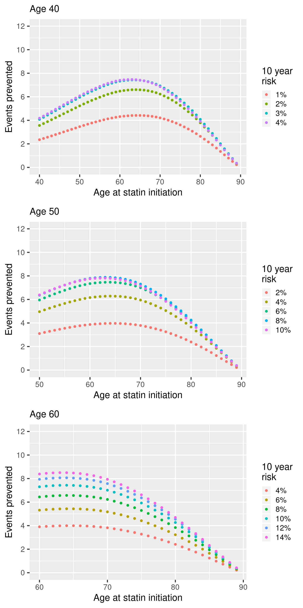

Supplementary Figure 3.15: Number of cardiovascular events prevented over the duration of follow up with different time delays in starting statins, stratified by baseline age and 10 year CVD risk using the discontinuation rates as observed in the statin cohort **(female cohort, RR = 0.7, single prescriptions excluded)**

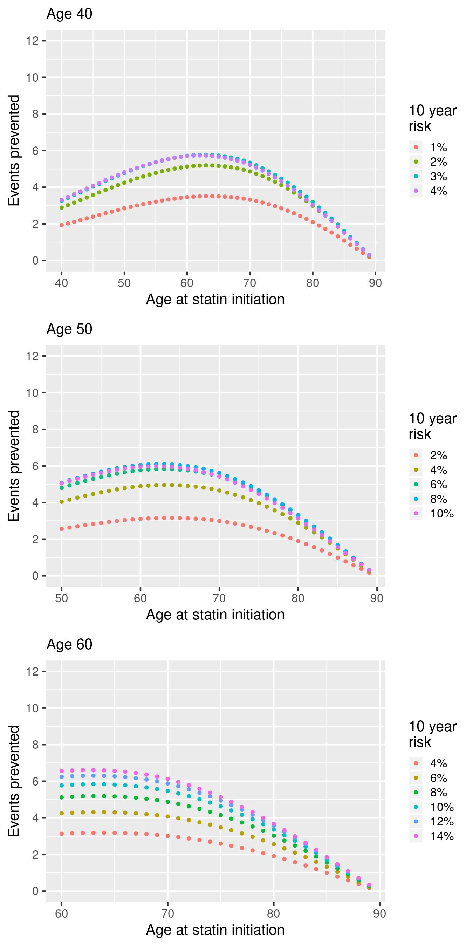

Supplementary Figure 3.16: Number of cardiovascular events prevented over the duration of follow up with different time delays in starting statins, stratified by baseline age and 10 year CVD risk using the discontinuation rates as observed in the statin cohort **(female cohort, RR = 0.65, single prescriptions excluded)**

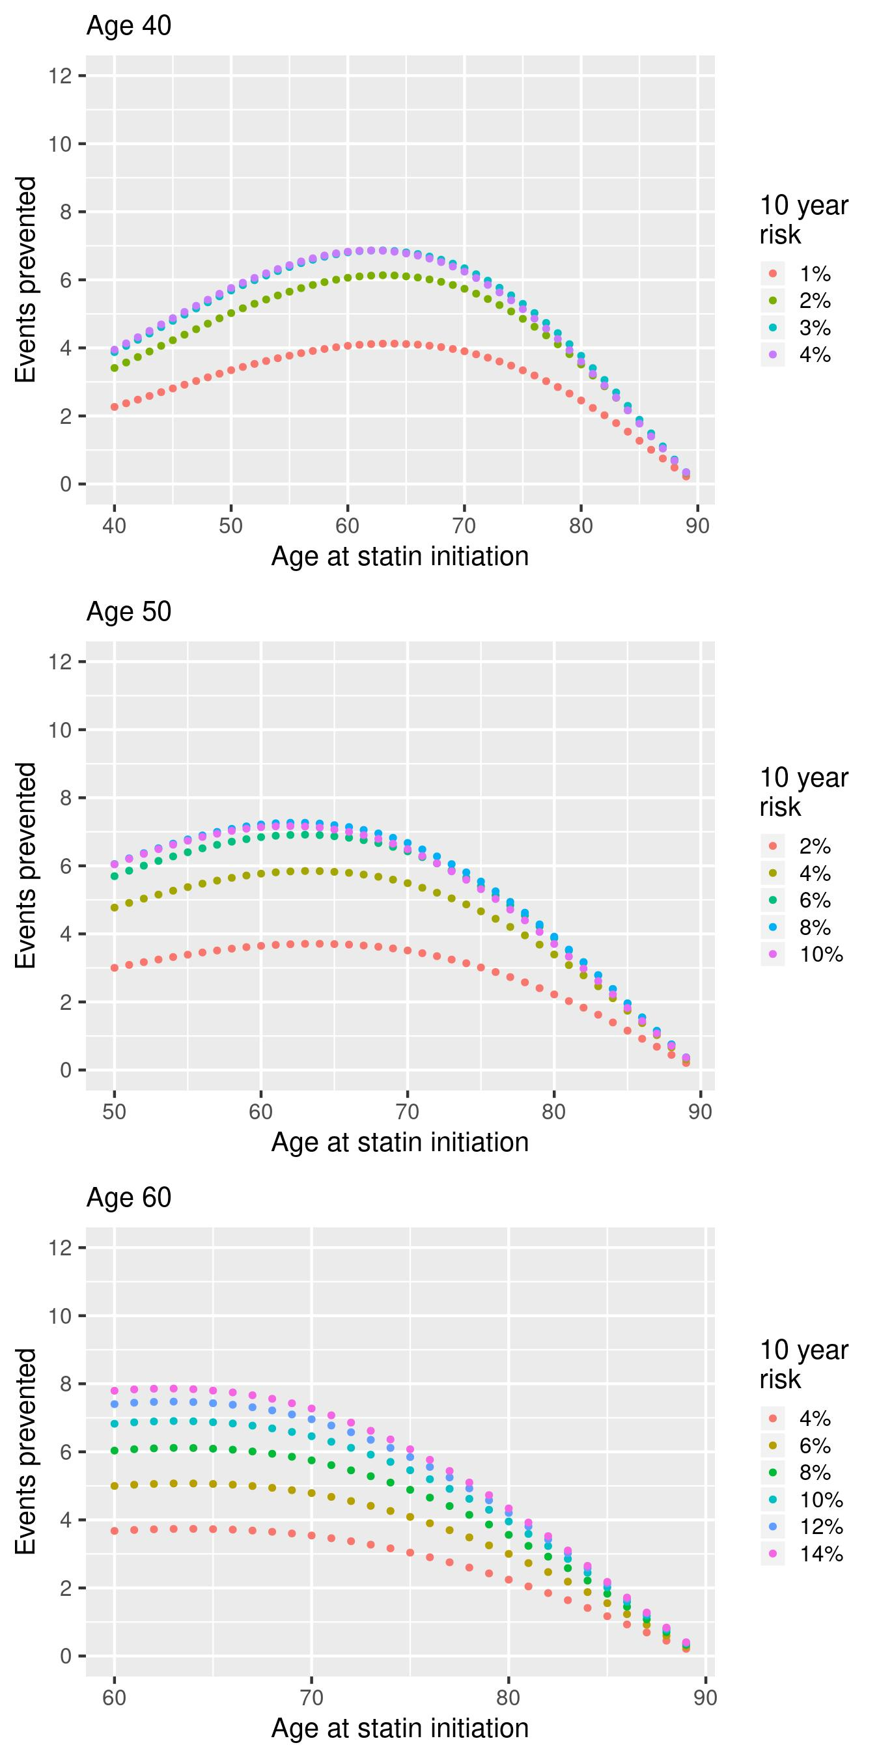

Supplementary Figure 3.17: Number of cardiovascular events prevented over the duration of follow up with different time delays in starting statins, stratified by baseline age and 10 year CVD risk using the discontinuation rates as observed in the statin cohort **(female cohort, RR = 0.6, single prescriptions excluded)**

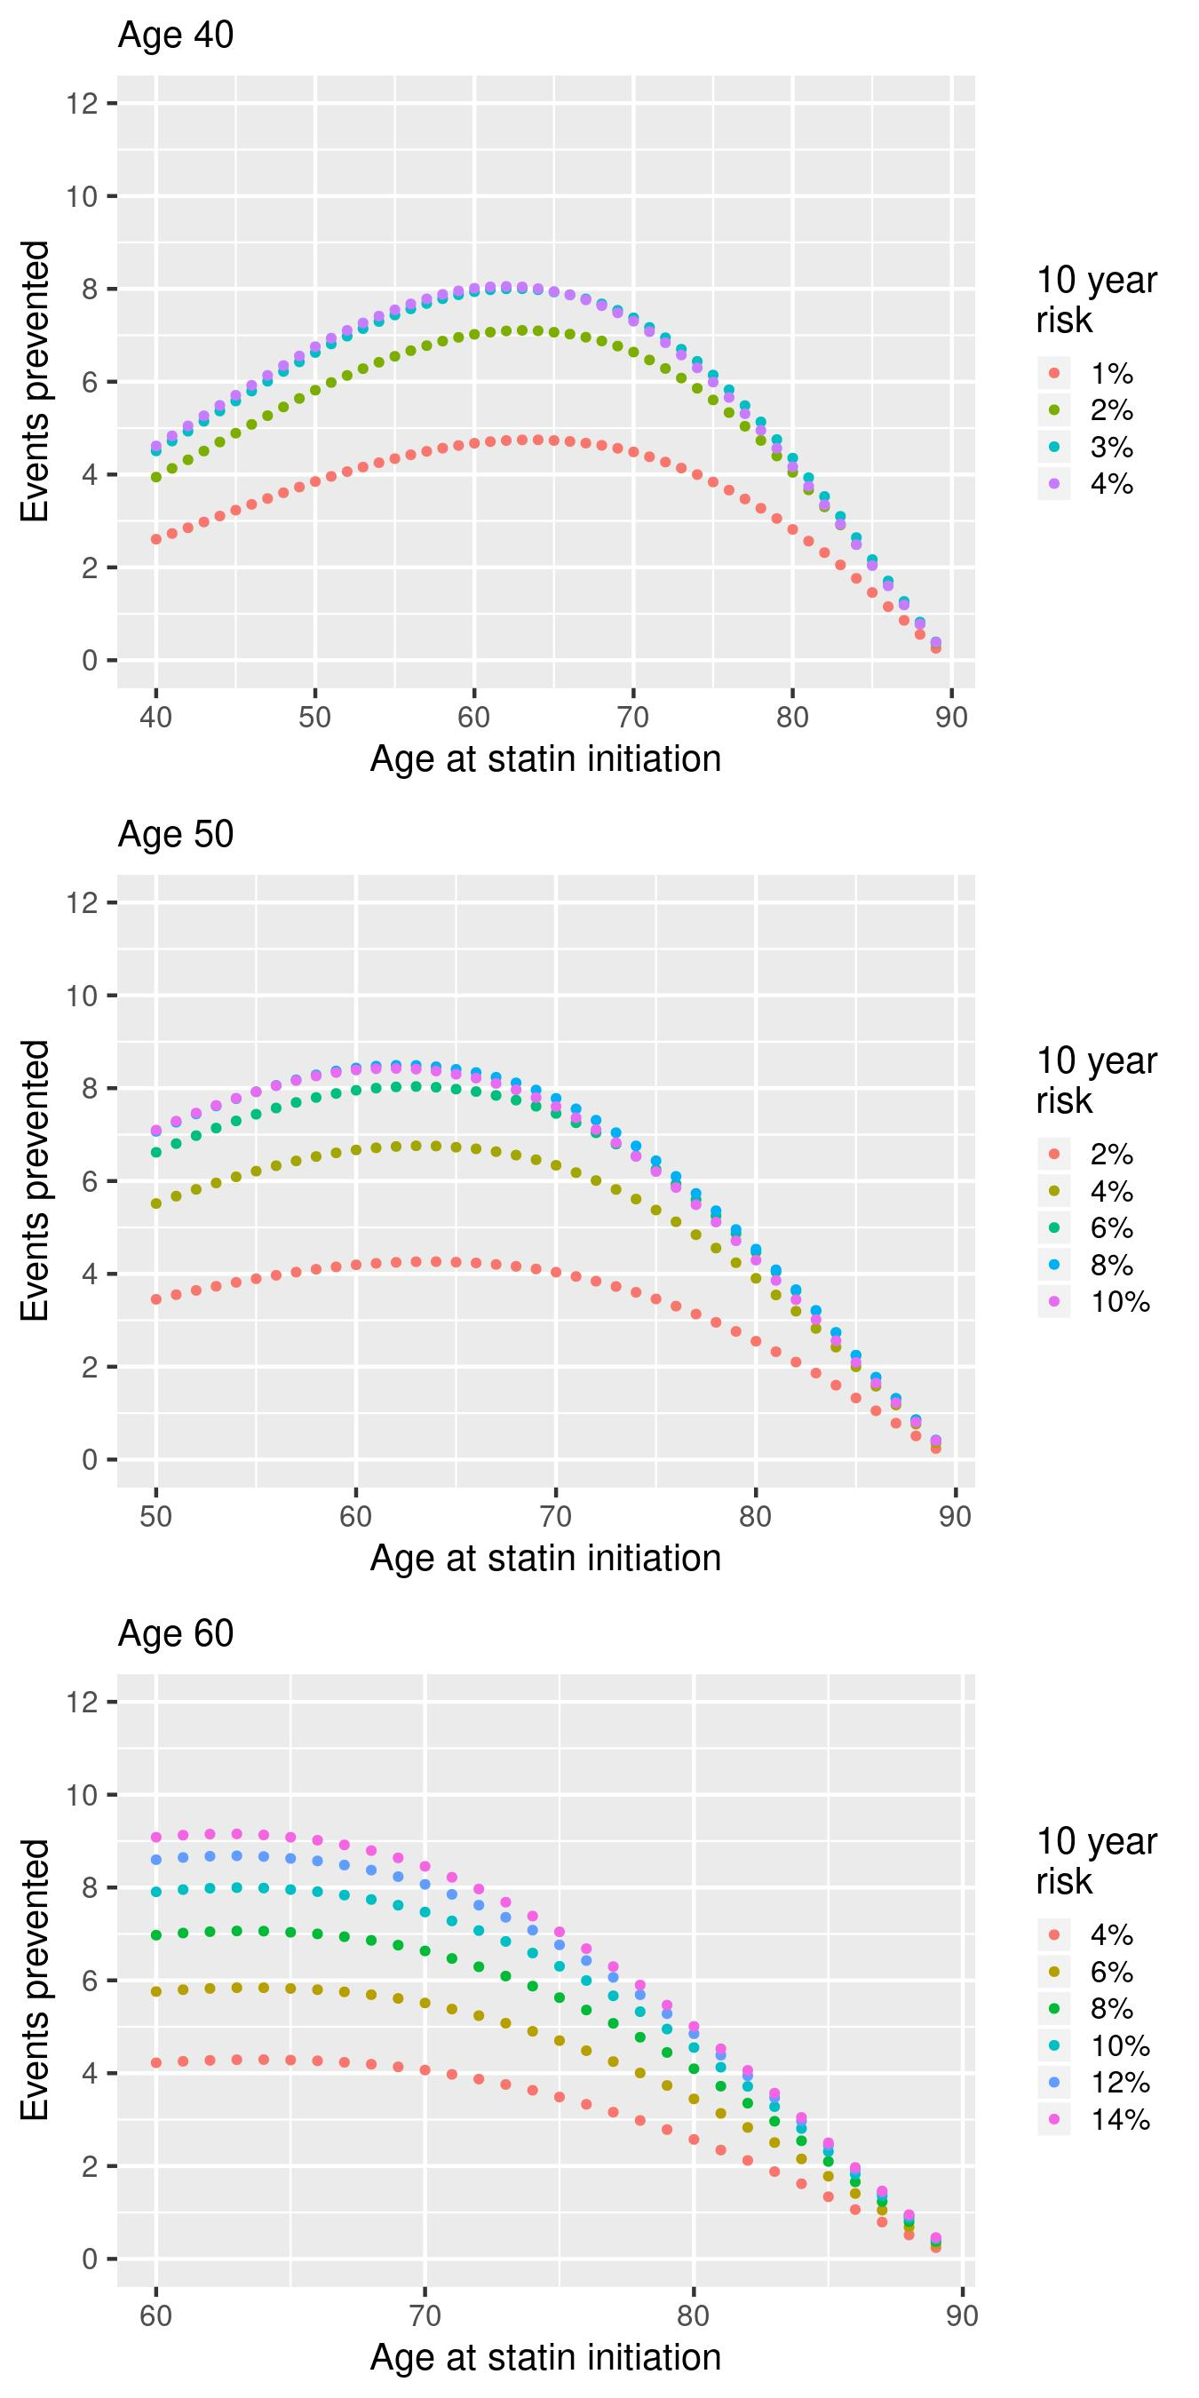

Supplementary Figure 3.18: Number of cardiovascular events prevented over the duration of follow up with different time delays in starting statins, stratified by baseline age and discontinuation rate **(female cohort, RR = 0.65)**

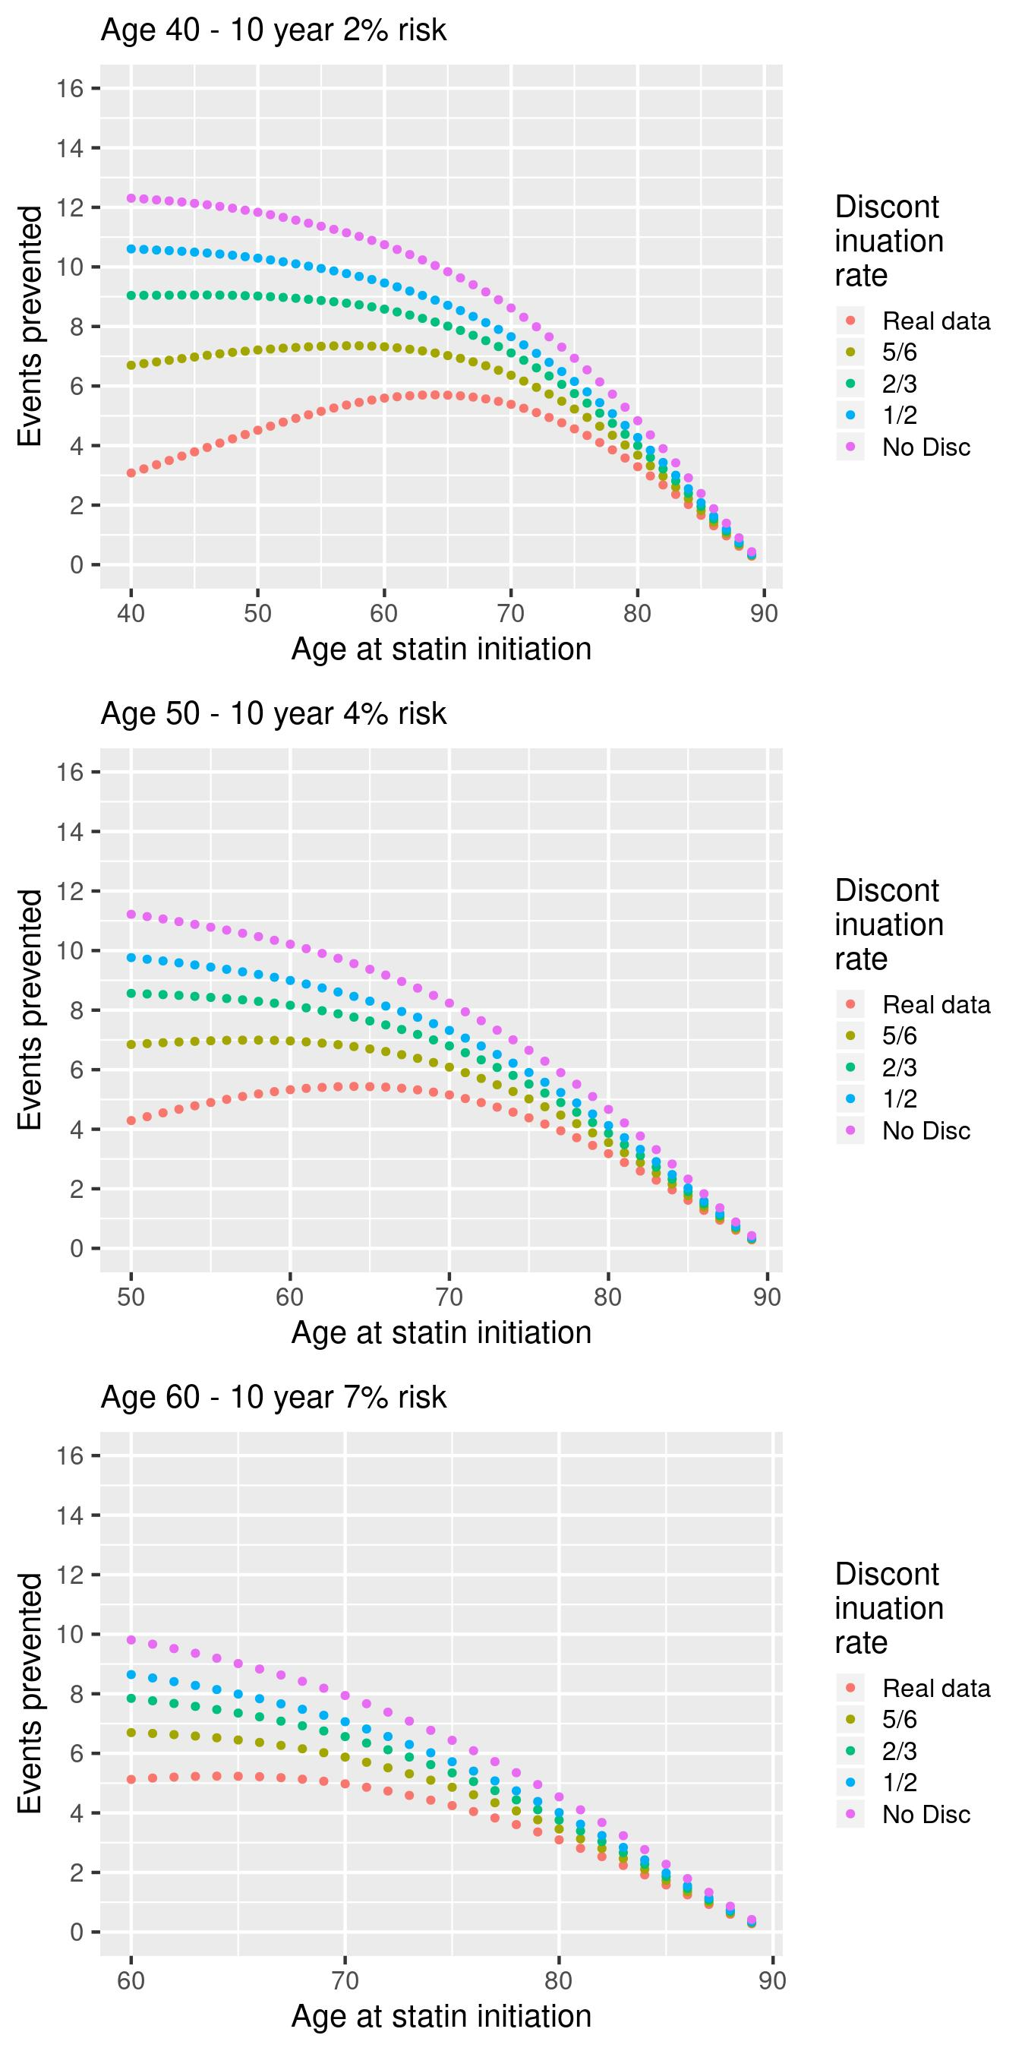

Supplementary Figure 3.19: Number of cardiovascular events prevented over the duration of follow up with different time delays in starting statins, stratified by baseline age and discontinuation rate **(female cohort, RR = 0.6)**

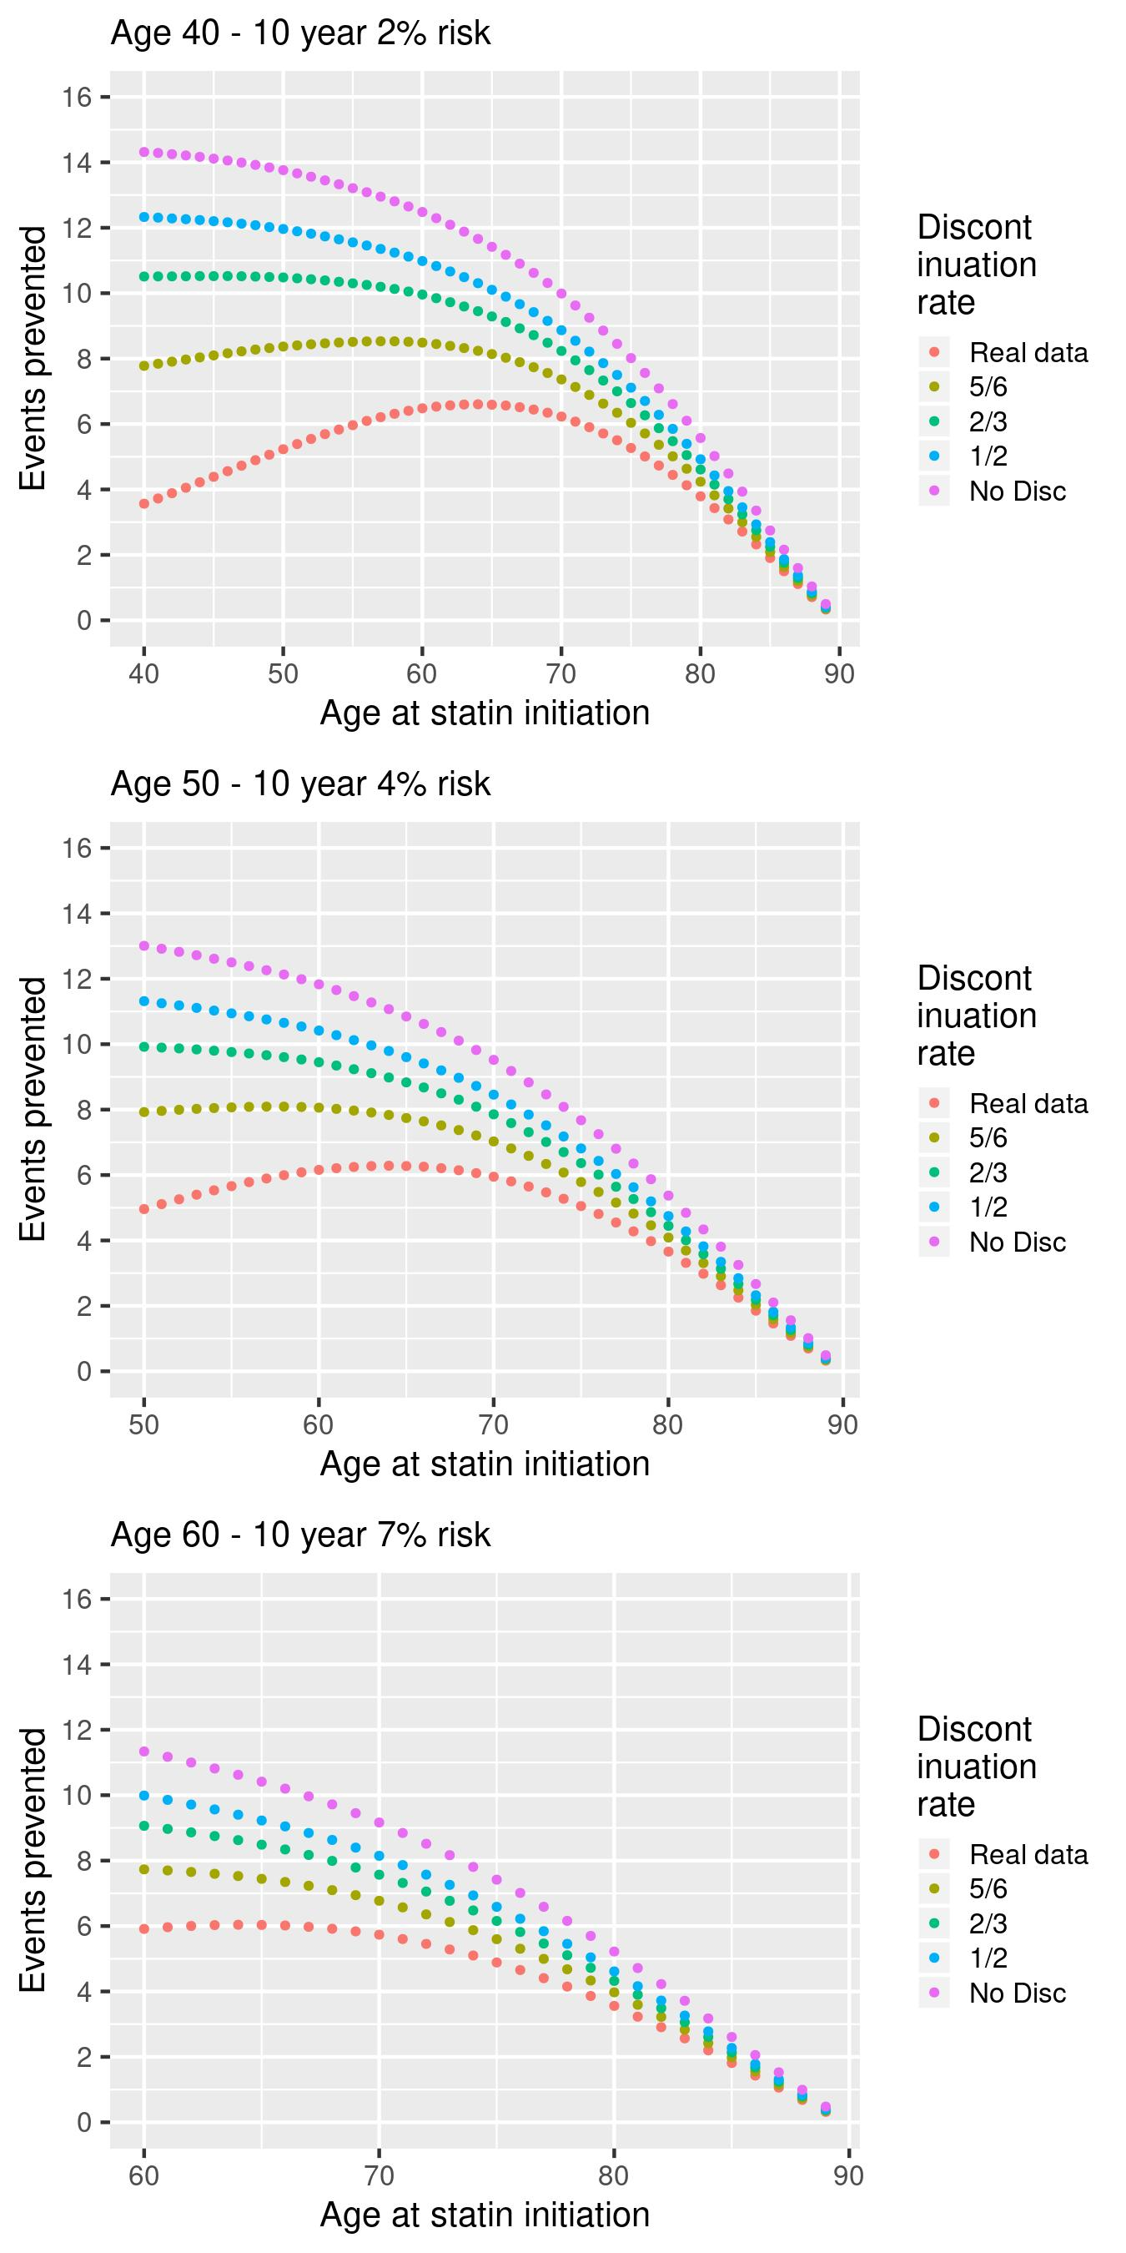

Supplementary Figure 3.20: Number of cardiovascular events prevented over the duration of follow up with different time delays in starting statins, stratified by baseline age and discontinuation rate **(female cohort, RR = 0.7, single prescriptions excluded)**

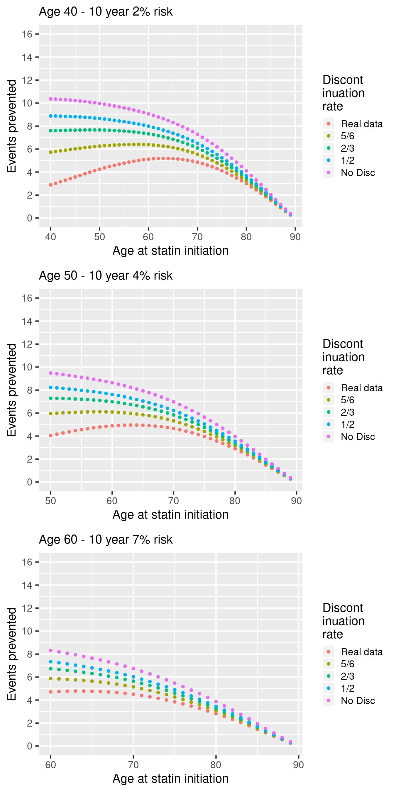

Supplementary Figure 3.21: Number of cardiovascular events prevented over the duration of follow up with different time delays in starting statins, stratified by baseline age and discontinuation rate **(female cohort, RR = 0.65, single prescriptions excluded)**

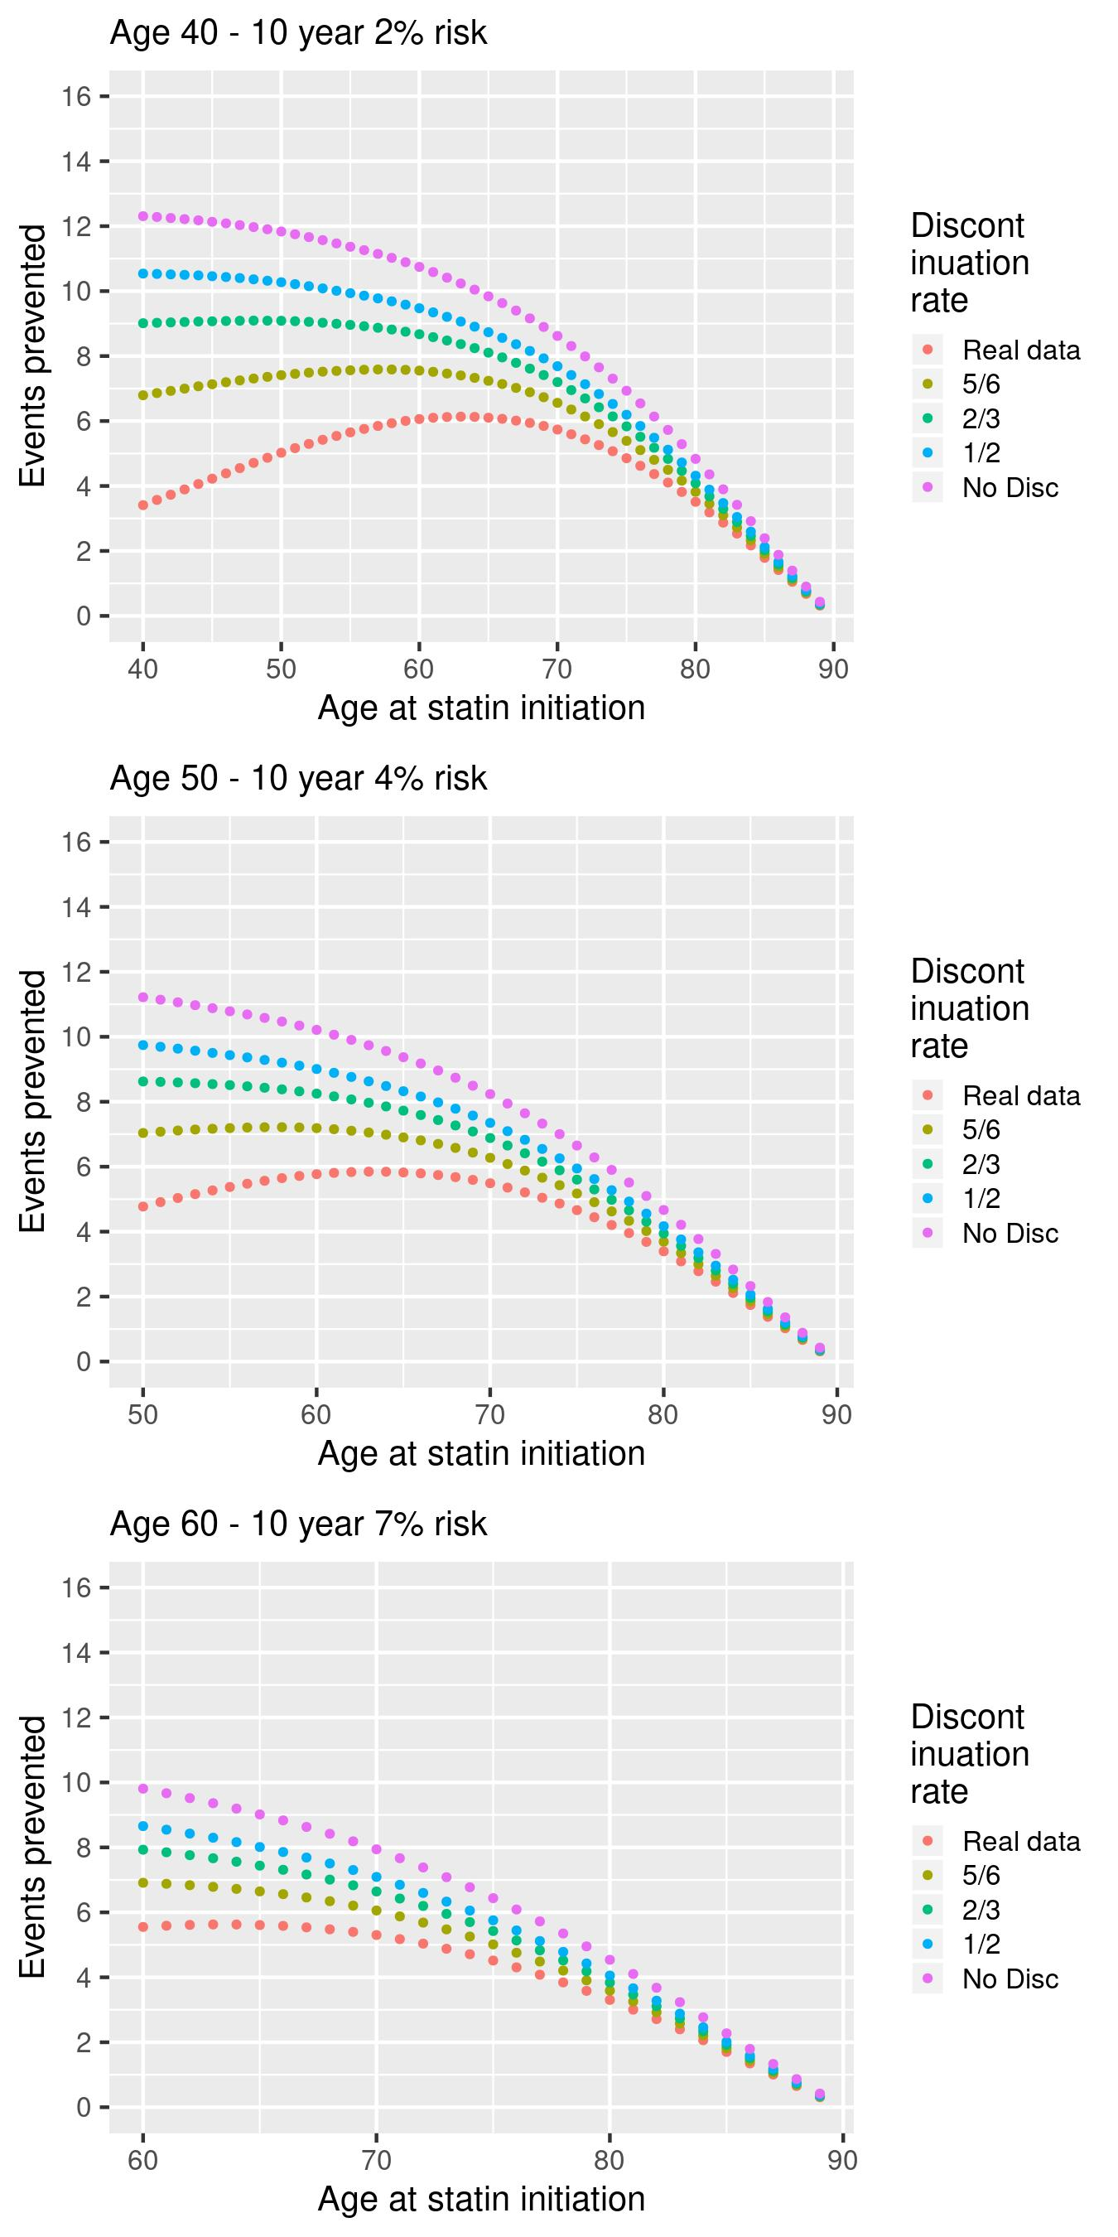

Supplementary Figure 3.22: Number of cardiovascular events prevented over the duration of follow up with different time delays in starting statins, stratified by baseline age and discontinuation rate **(female cohort, RR = 0.6, single prescriptions excluded)**

